Lab2 continued

P1. Prove by induction that for all n > 4, Fn > 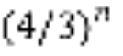. Then use this result to explain the approximate asymptotic running time of the recursive algorithm for computing the Fibonacci numbers. Is the recursive Fibonacci algorithm fast or slow? Why? Hint #1. For the base case of your proof, the following table of values may be useful:

Solu:
Base case: From the table, we know F(4) > 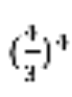, F(3) > 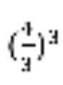, F(2) > 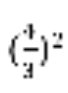.
Induction step: For F(n), if n>4
F(n+1) – 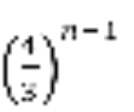= F(n) + F(n-1) - > 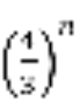 + 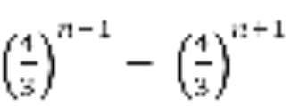 = 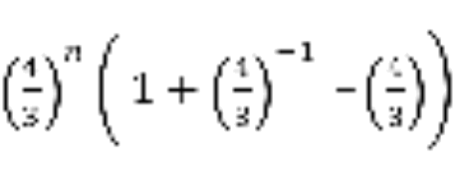 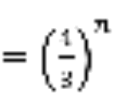(1 + 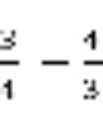 ) = 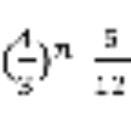 > 0
Conclusion: for all n > 4, F(n) > 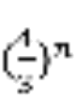.

.
T(n) = T(n-1) + T(n-2) + 1 = T(n-2) + T(n-3) + 1 + T(n-3) + T(n-4) + 1 + 1 = T(n-3) + T(n-4) + 1 + T(n-4) + T(n-5) + 1 + T(n-4) + T(n-5) + 1 + T(n-5) + T(n-6) + 1 =…

In each step we call T twice, thus will conclude below:
T(n) = 2⋅2⋅...⋅2 + c = 2ⁿ + c;
T(n) = O(2ⁿ) is very slow.

P2. More big-oh: (Work with someone who is familiar with limits)
a. True or false: 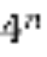 is O(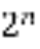). Prove your answer.
b. True or false: log n is Θ(log3 n). Prove your answer.
c. True or false: (n/2) log(n/2) is Θ(nlog n). Prove your answer.

Solu:
- False.
For each c, while n>logc, we have >*c
So is not O().

- True.
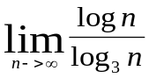 = 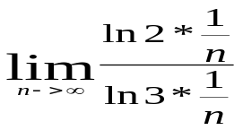=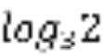
So log n is O(log3 n),
And 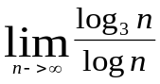 = =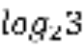
So log3 n is O (log n),

So log n is Θ(log3 n).

- True.
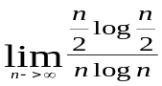=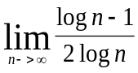=1/2
So (n/2) log(n/2) is O(nlog n),

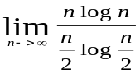 =2

So nlog n is O( (n/2) log(n/2)),

So (n/2) log(n/2) is Θ(nlog n),

P3:
A,
- T(1) = 1
- T(2) = T(1) + 1 = 2
- T(3) = T(2) + 1 = 3
- T(4) = T(3) + 1 = 4
- ...
- T(n) = n
the worst-case asymptotic running time of this algorithm O(n)
Induction step:
T(1) = 1, T(n) = n,
T(n+1) = T(n) + 1 = n+1;
B:
Valid Recursion Base case is “n= 0 or n=1”. Each self-call reduces input size by 1, so eventually base case is reached
Base The values 0! and 1! are correctly computed by the base case
Recursion Assuming recursiveFactorial(n-1) correctly computes n-1!, we must show output of recursiveFactorial(n) is correct. But output of recursiveFactorial(n) is
n * recursiveFactorial(n-1) = n!, as required.
Therefore, the algorithm correctly computes n! for every n.

P4.
Solu:

Code: cost*times
int Fibonacci(int n) {
if(0 == n) return 0; c1+c2
if(1 == n) return 1; c1+c2
int f1 = 0, f2 = 1; c3

for (int i = 2; i <= n ; i++) { c3+c1*n+c4*(n-1)
f2 = f1 + f2; c5*(n-1)
f1 = f2 - f1; c5*(n-1)
}
return f2; c2
}

Per cost*times shown above, the running time is easily calculated as O(n).

Proof:
We identify the loop invariant for the for loop:
I(2n)=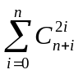, I(2n+1)=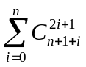
Base case: For n=0, we have I(0)=0, I(1)=1.

Induction Step: I(2n+2)=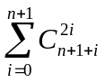=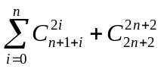=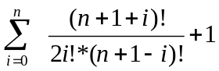
=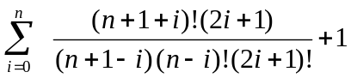
=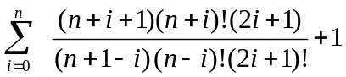
=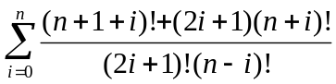
=
= 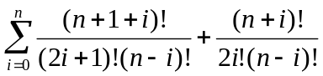
=+

Then proved.

P5:
Solu:
As shown above, it is available to use the Master Formula:
And the parameters are: a=1,b=2,c=1,d=1,k=1
Because a<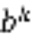
T(n) = (n)

P6:
The worst-case: all elements are 0s or all elements are 1s
T(n) = T(n/2) + T(n/4) +… + T(1) = O(log n) = o(n)

